**Sporty Shoes (Spring Boot Application)**

**UI and features**

A good looking attractive Dynamic Front Page

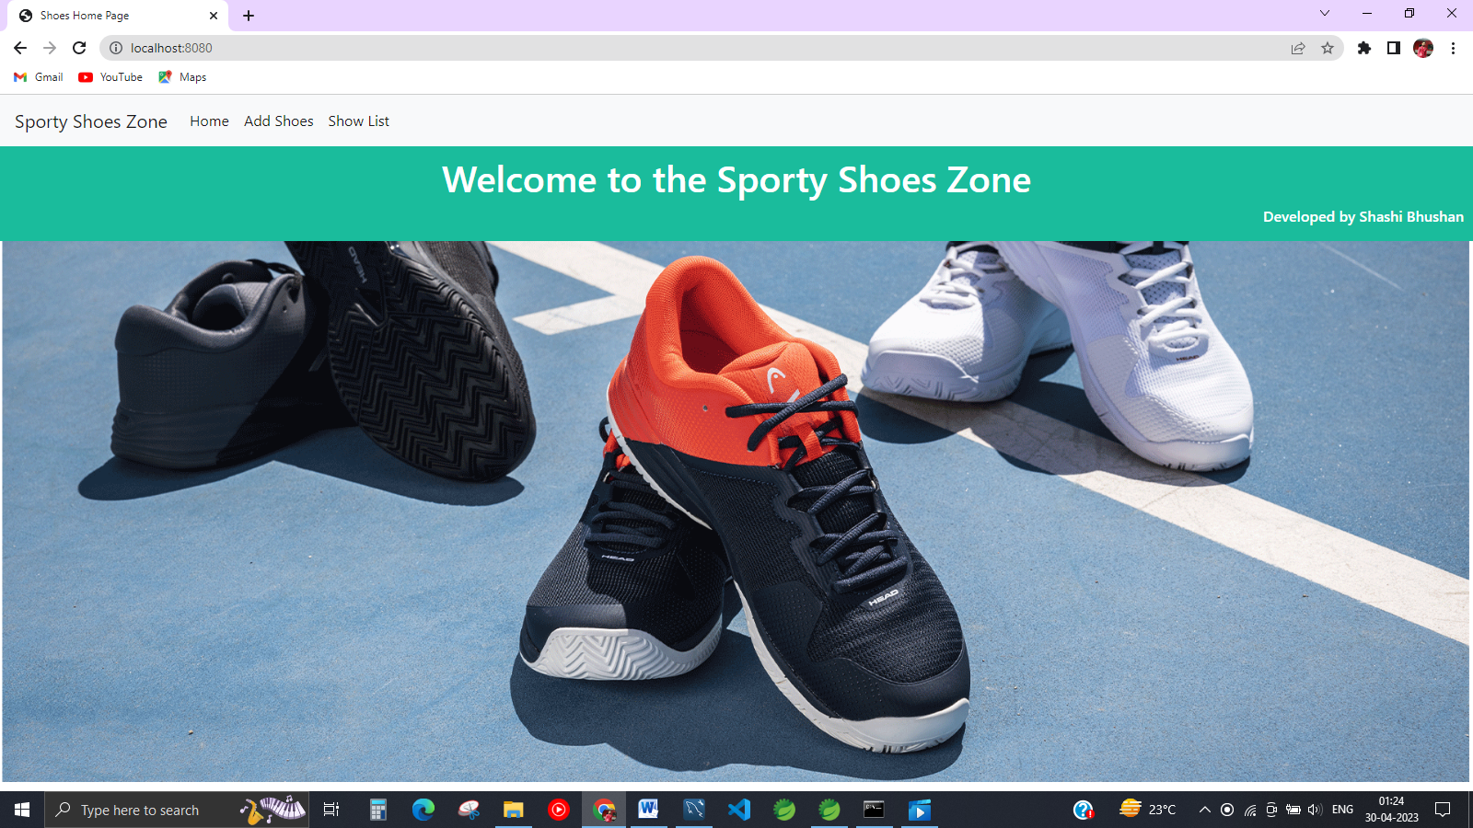

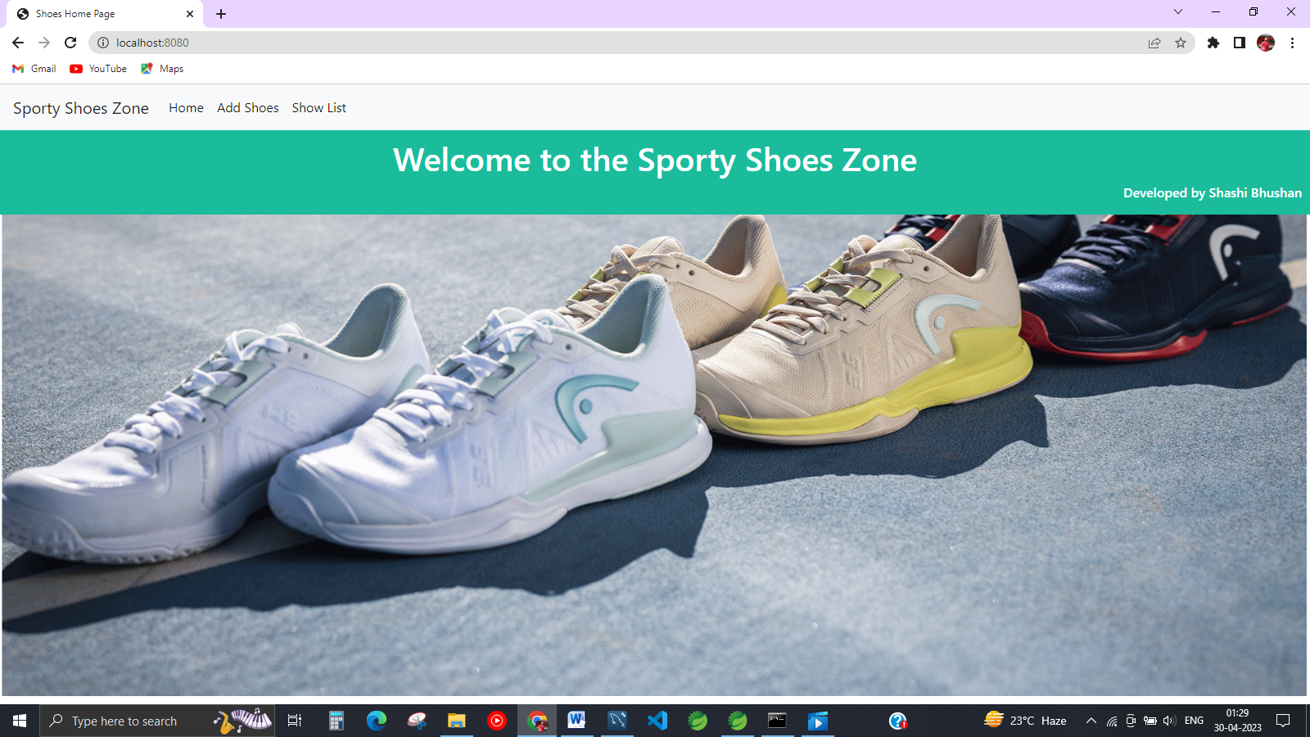

**Key Features :**

1. Admin will have access to store shoe data and shoe collection detail.
2. Admin can see all Shoe data together. And can track details by their unique ID or by serial no.
3. Admin have access to update existing data.
4. Admin can delete discontinued Shoes.

**Application Demo**

**Adding Shoe**

Steps : To add Shoe data Go to > Add shoes Detail

For the better recognition required Inputs is :

1. Shoe ID : a special unique shoe ID
2. Shoe Brand : Brand name
3. Shoe Category : in which category this shoe falls i.e sporty, formal or sneakers
4. Shoe price :
5. Shoe Description : shoe information

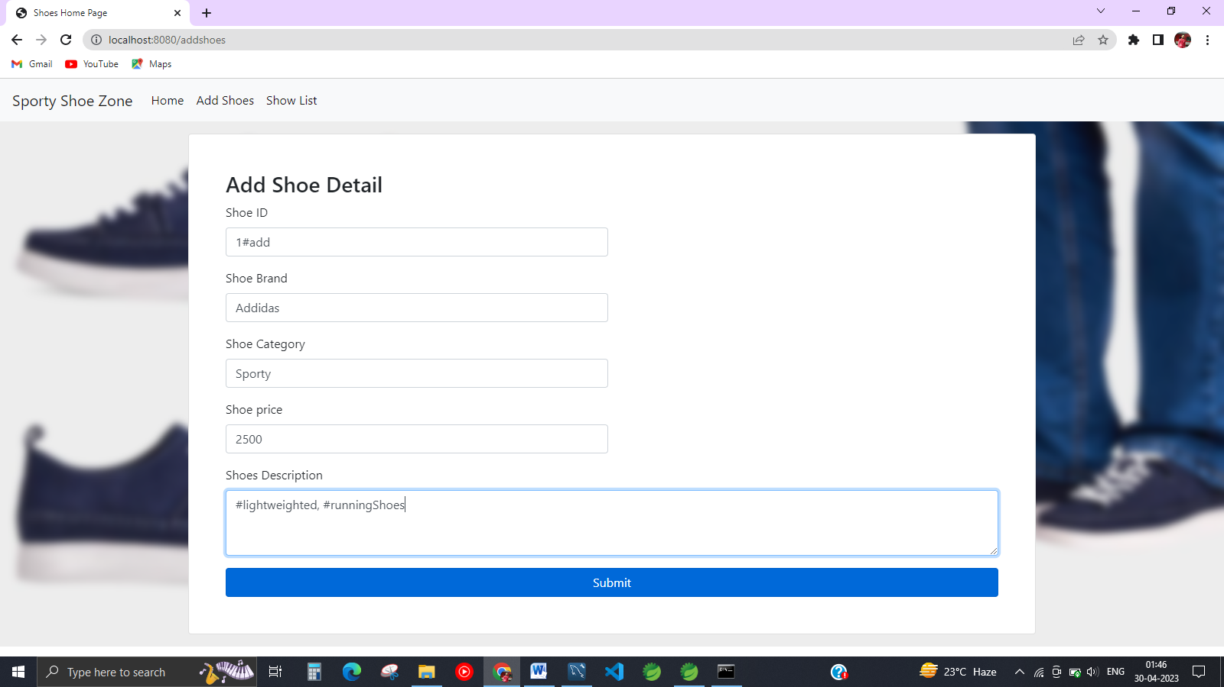

After clicking submit data will save in backend database

**Shoe List**

Admin can check Shoe availability from list

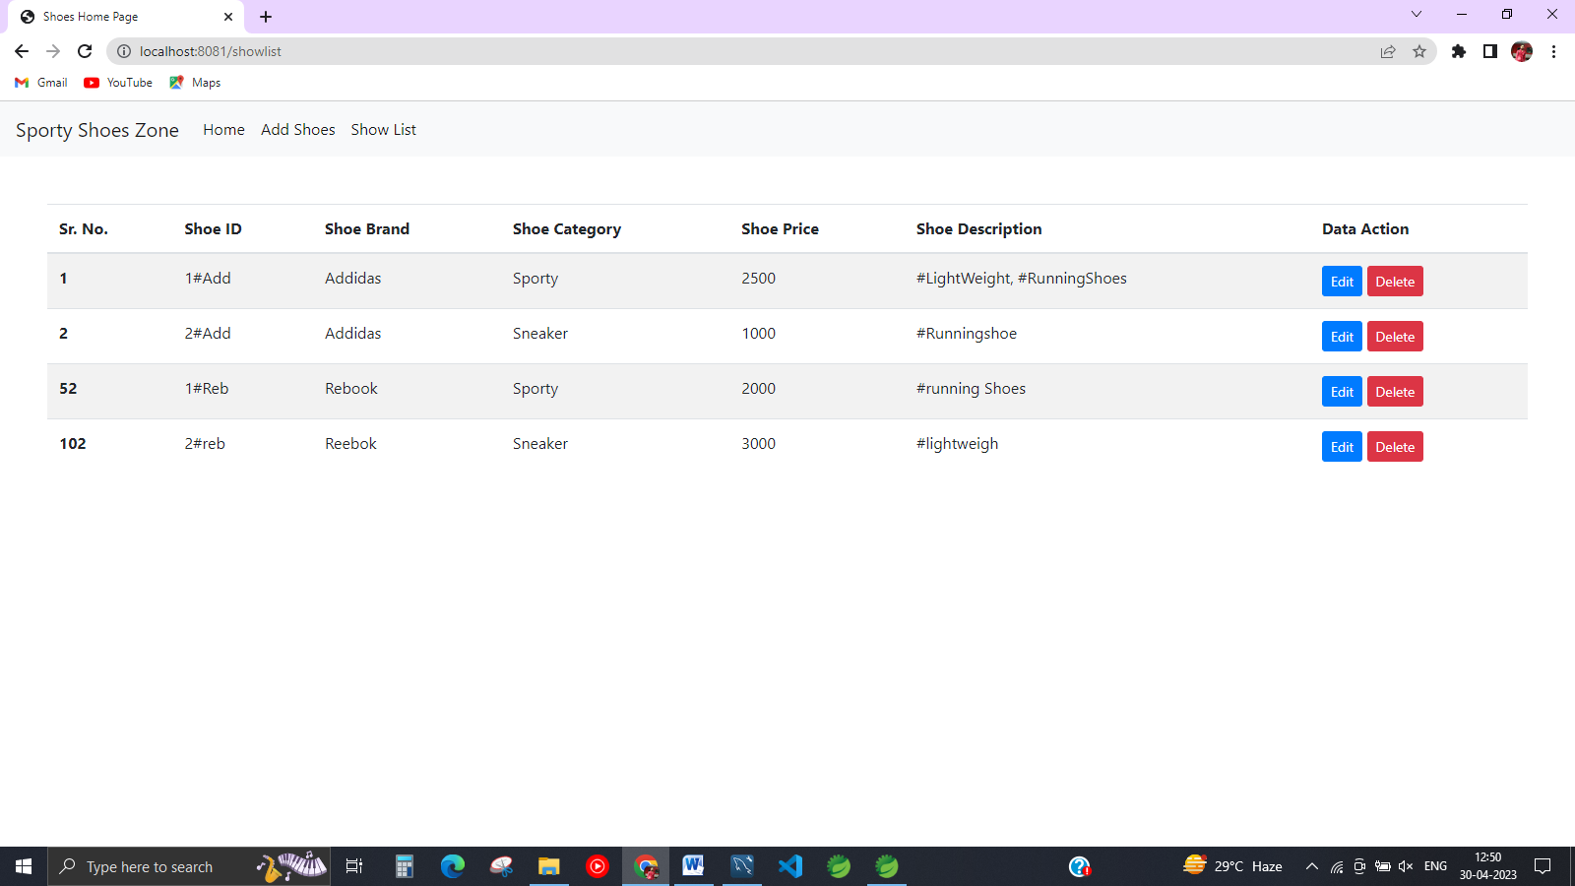

Backend MySQL database Data save

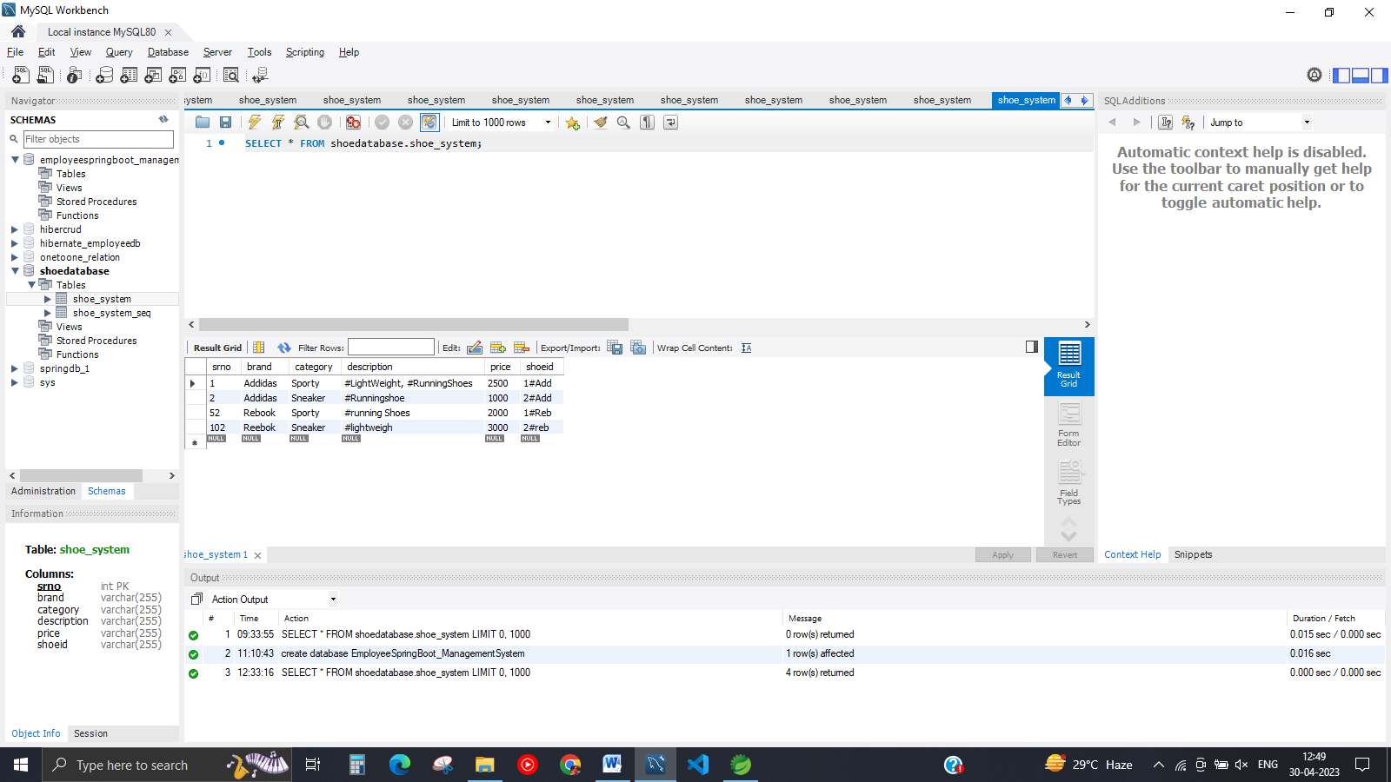

**Admin Can Edit Data**

Example: let’s revise price sr. no 202 from 3000 to 2000

You will get data filled as it is , Only need to change required data like here we want only to change price.

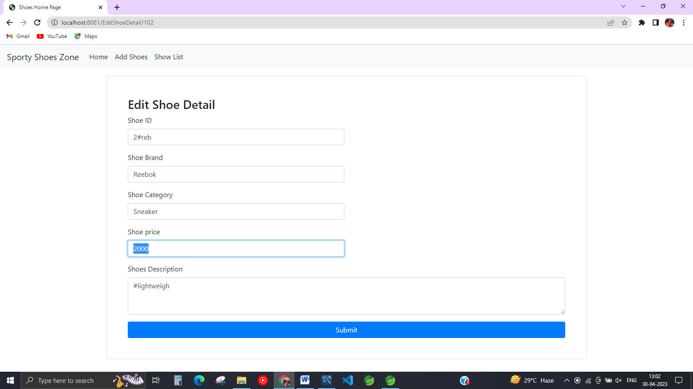

Changes Result is here

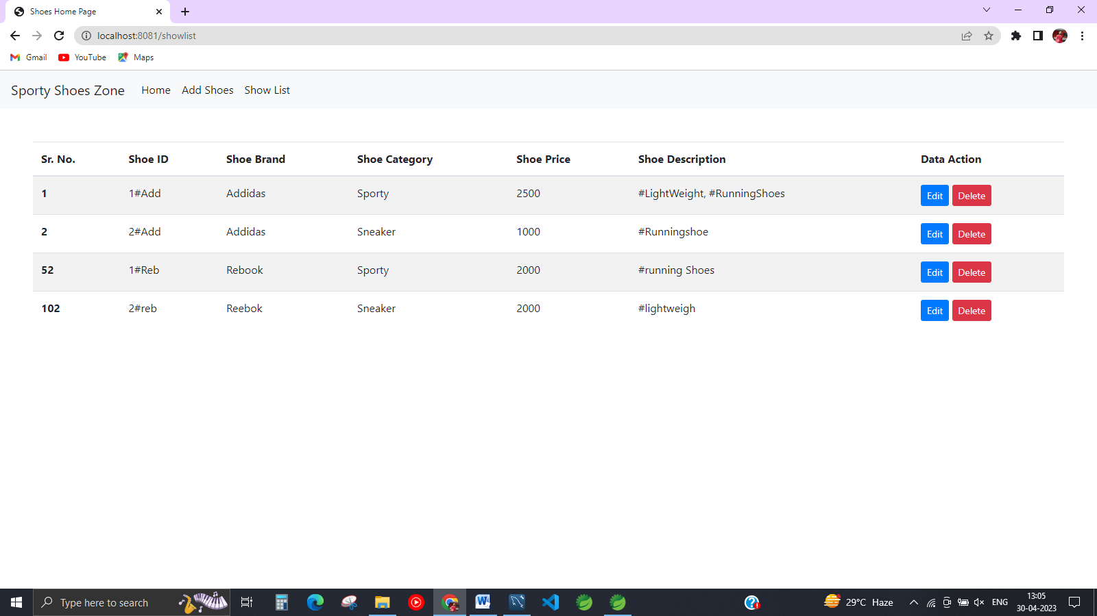

Price change from 3000 to 2000

**Delete Data**

Admin can delete data in just one shot

Like I deleted two mid row can see in list.

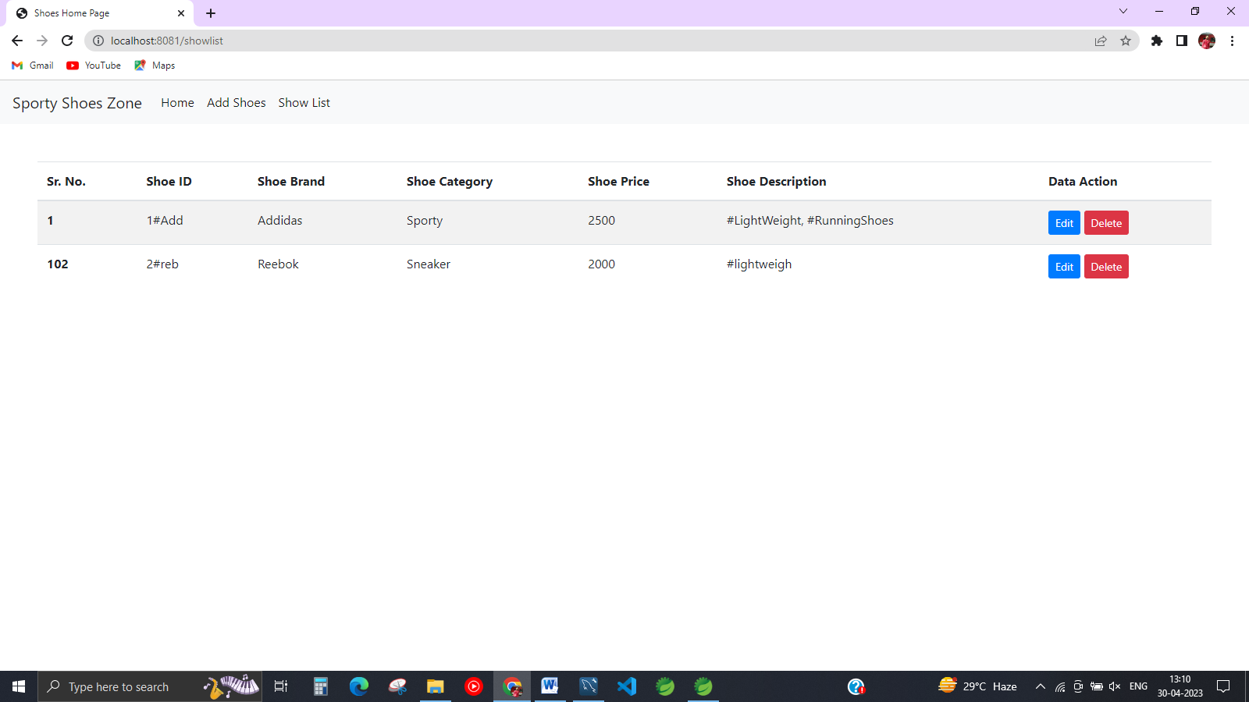

Can see updated in database as well price updated and two rows deleted.

